|  |  |
| --- | --- |
| Why is Software Engineering important and why is it different from computer  science? - European Leadership University  COCSC-11 SOFTWARE ENGINEERING  PRACTICLE FILE | NAME: AMOGH GARG  ROLL NUMBER: 2020UCO1688  BRANCH: COE  SECTION: 3  AMOGH GARG |

Contents

PROBLEM STATEMENT 2

SOLUTION 3

ER DIAGRAM 4

DATA FLOW DIAGRAM 5

CONTEXT DAIGRAM 5

LEVEL-1 DIAGRAM 6

DATA DICTIONARY 7

PROCESS SPECIFICATION 9

PROCESS LOGIN /REGISTRATION 9

SHOW FEEDS 9

STATE TRANSITION DIAGRAM 10

ATM MACHINE 10

CD PLAYER 11

FUNCTIONAL REQUIREMENTS 12

NON-FUNCTIONAL REQUIREMENTS 14

USABILITY REQUIREMENT: 14

AVAILABILITY & EFFICIENCY REQUIREMENT: 14

COST: 14

ACCURACY: 14

SECURITY: 14

PERFORMANCE REQUIREMENTS: 15

STORAGE: 15

CRITICAL PATH METHOD 16

BOUNDARY VALUE ANALYSIS 18

CYCLOMATIC COMPLEXITY……………………………………………………………………………………………………….19

# PROBLEM STATEMENT

Many times it so happens that students at NSUT are able to arrange the previous year question papers for themselves, but they are unable to find solutions to those questions. Previous year question papers are available on various platforms like NSUTx and NSUT-Resources but these platforms do not provide proper means for the students to access the solutions of these papers. The problem here is to devise a mechanism which will make solutions to these question papers accessible to the students at NSUT. Apart from this, students should also be able to ask doubts separately which are not part of previous year question papers. This would also increase the interaction amongst students from different branches, year and even interact with professors.

The solution to this problem should ensure that the answers of the previous year question papers are accessible with ease and no special training and configuration is required from the client-side. Only those who belong to NSUT i.e. either students or professors should be able to utilize this facility.

The solution should ensure proper security of the data and should be reliable in terms of availability and efficiency. It should also be cost effective in order to maximize the number of users in the form of professors and students so that everyone in the university can benefit from this facility. Proper checks should be done to prevent the violation of the terms of use and rules which are made by the university in order to ensure a formal and productive utilization of this facility.

Therefore, the solution should be such that it should be able to meet all of the above requirements and yet be simple in its usage.

# SOLUTION

Our proposed solution is to develop software which will allow students of the university to discuss the Previous question paper with each other and with the professor.  
There will be a separate discussion forum for each paper which will be uploaded. When selecting a particular question-paper, a discussion forum will open where students can post their doubts and questions. The discussion forum will be question specific so that users can find answers to their specific problems if the problem has already been discussed. In each discussion forum, faculty responses and solutions will be kept separate as expert solutions.

Additionally, there will be a feed section where students can post their question irrespective of any question paper, the questions that are recently posted, regardless of whether they are in question papers or posted independently, will be displayed in the feed section. Also, there is a section for searching questions and narrowing them down by semester, subject and topic.   
Users can upload their solutions in jpg/jpeg/pdf/png formats. They will also be able to upvote a solution. NSUT students and faculties will be the only ones able to register with the technology.   
The scope of the software can be expanded to include other universities. All the user data such as the University roll number and password will be stored on a cloud based database that is securely encrypted to preclude the data from being misused by unauthorized sources. Apart from this the UI will be fast, interactive and easy to use.

# ER DIAGRAM

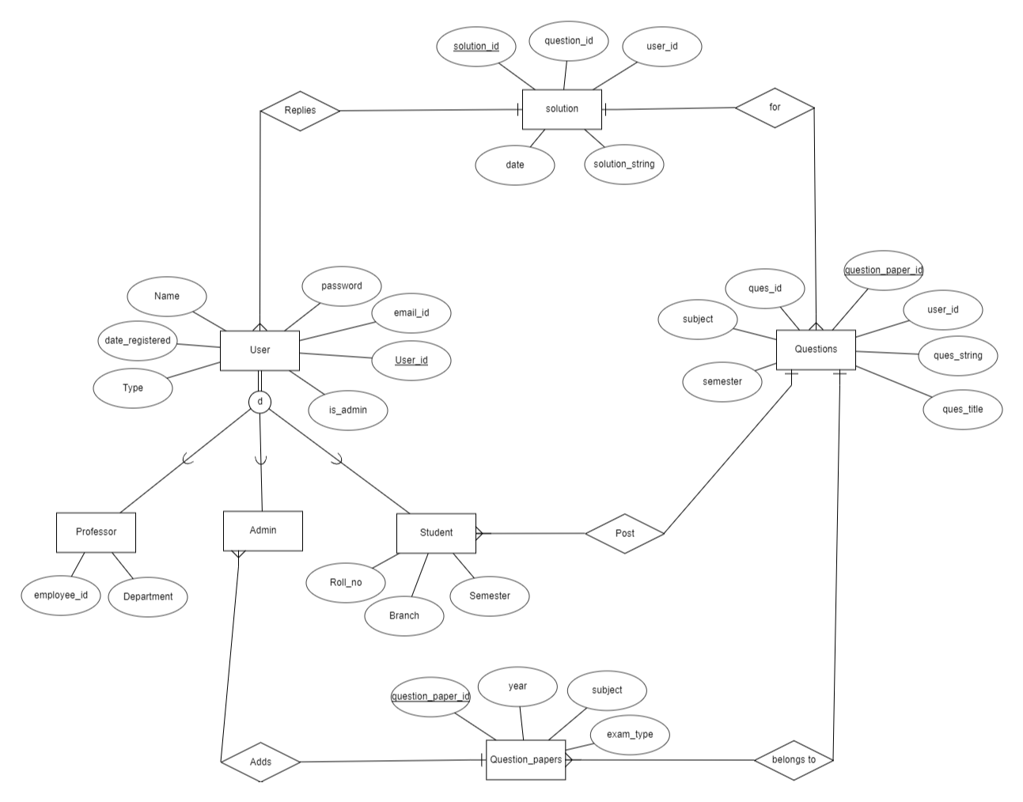

# DATA FLOW DIAGRAM

## CONTEXT DAIGRAM

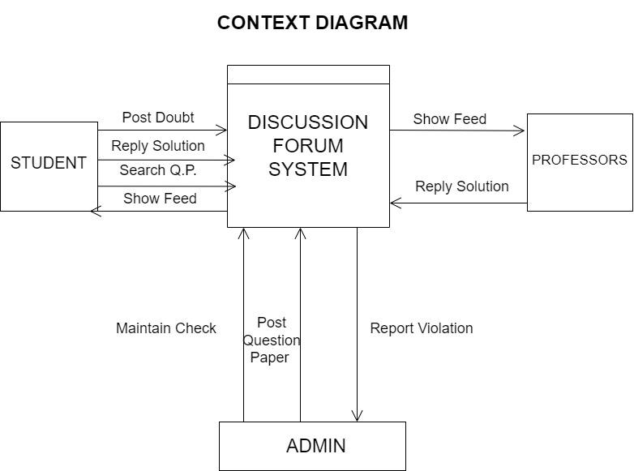

## LEVEL-1 DIAGRAM

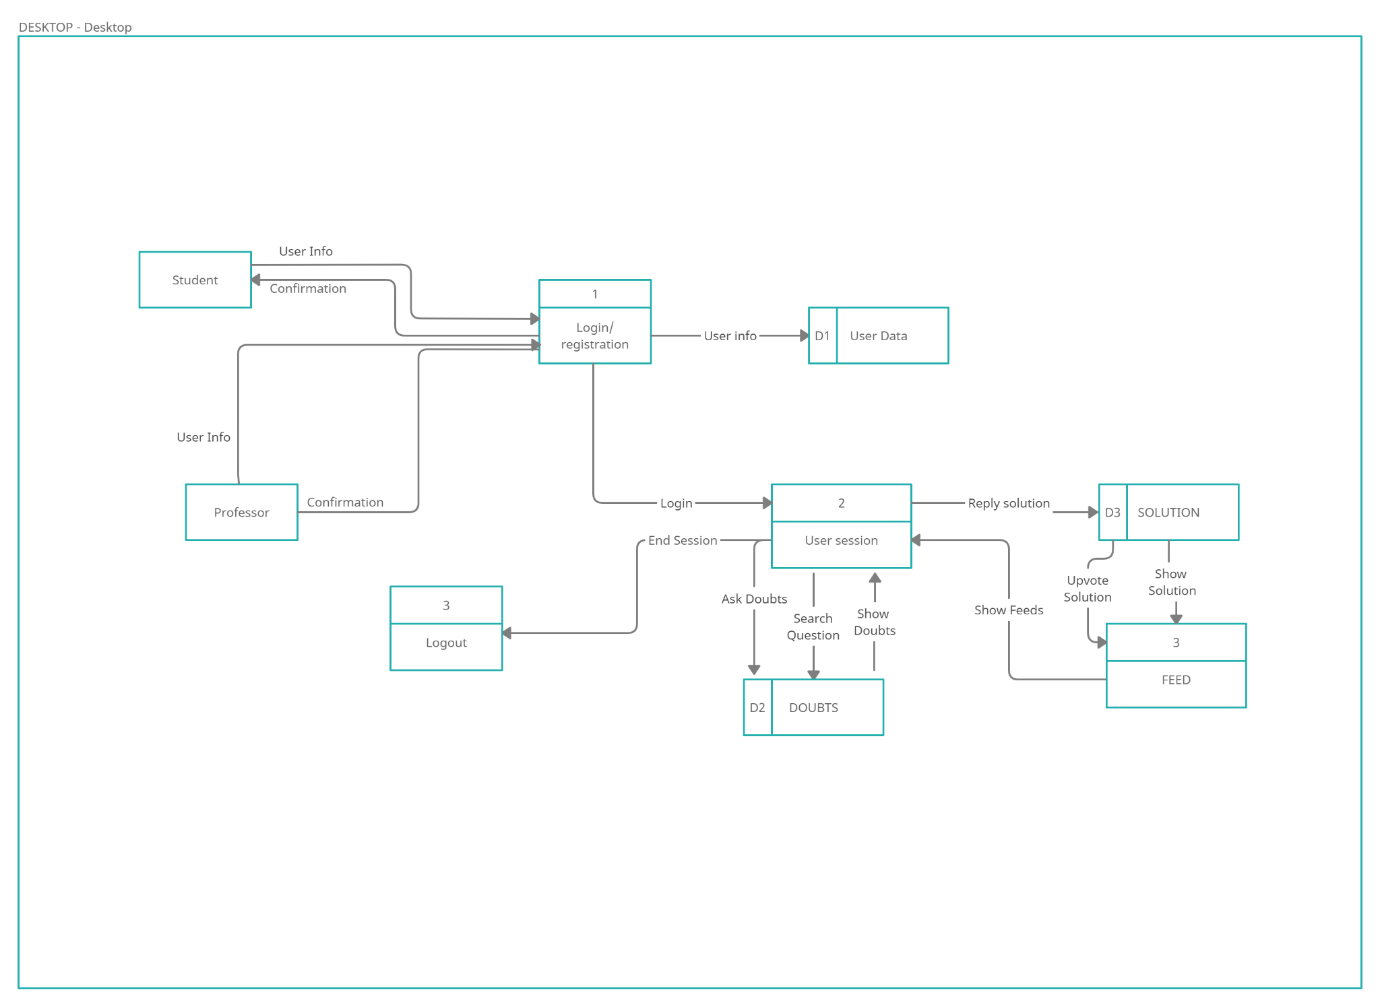

# DATA DICTIONARY

|  |  |  |  |  |  |
| --- | --- | --- | --- | --- | --- |
| **ATTRIBUTE** | **ENTITY** | **DATA TYPE** | **DESCRIPTION** | **RANGE OF VALUES** | **VALIDATION** |
| Name | User | Char | Name of the user | 1-30 chars |  |
| Password | User | Varchar | Login Password | At Least 8 chars | Must be at least 8 chars long with one special char |
| Email_ID | User | Varchar | Registered email-id | 1-50 chars | Must contain @ symbol |
| User_ID | User | Integer | User-ID/Username | Exact 8 digits | Must be unique |
| Is_Admin | User | Boolean | Is user admin or not | True/False |  |
| Type | User | Char | Is user a student or professor | “Student”/ “Professor” |  |
| Date_Register | User | Date | Date of Registering | Date | =Current Date |
| Employee_ID | Professor | Integer | Employee_ID of professor | Exact 6 digits | Must be unique |
| Department | Professor | Char | Department of professor | 1-50 chars |  |
| Roll_No | Student | Varchar | Roll-number of the student | Exact 11 digits | Of the form “2020UCO1688” |
| Branch | Student | Char | Branch of the student | 1-30 chars |  |
| Semester | Student | Integer | Current semester of student | 1 digit | Must be between 1-8 |
| QuestionPaper_ID | Question_Papers | Integer | ID of the question-paper | 6 digits | Must be unique |
| Year | Question_Papers | Integer | Question-Paper year | 4 digits | Exactly 4 digits |
| Subject | Question_Papers | Char | Question-Paper subject | 1-30 chars |  |
| Exam_type | Question_Papers | Char | Mid Sem/End Sem/CT | 1-10 chars | “Mid Sem”/ “End Sem”/ “CT” |
| Ques_ID | Questions | Integer | ID of the question | 8 digits | Must be unique |
| Ques_Title | Questions | Varchar | Title of the question | 1-30 chars |  |
| Question_string | Questions | Varchar | Text of the question | 1-1000 chars |  |
| Solution_ID | Solution | Integer | ID of the solution | 8 digits | Must be unique |
| Solution_string | Solution | Varchar/Media | Text of the solution | 1-5000 chars/Image/Pdf |  |
| Date | Solution | Date | Date of posting the solution | Date |  |

# Process specification

## Process Login /registration

Specification by Structured English:

IF registered

INPUT email_id

INPUT password

IF password is correct

SET userId = email_id

ELSE

PRINT “Wrong username or password”

RESET

ELSE

INPUT name

INPUT email_id

INPUT password

INPUT Is Professor or is Student

IF email_id not registered

Register User

SET userid = email_id

## Show Feeds

Specification by Pre/Post Conditions:

**Pre-Condition1:** user has a valid email_id and password

**Post-Condition1**: Get all the recent Doubts From Doubts

**Pre-Condition2:** Pre-Condition1 fails for any reason

**Post-Condition2:** Display error message

# STATE TRANSITION DIAGRAM

## ATM MACHINE

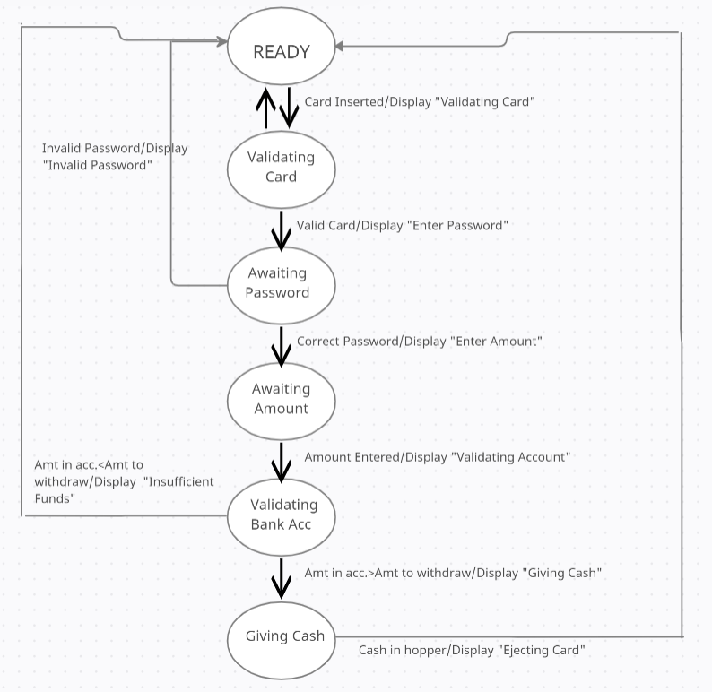

## CD PLAYER

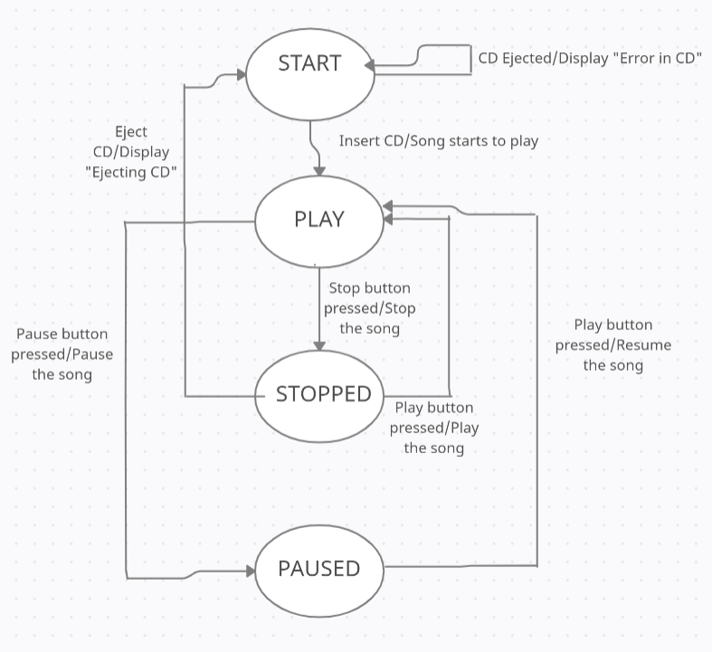

# SRS-FUNCTIONAL REQUIREMENTS

## **R.1. REGISTRATION MODULE** First-time users will have to register on the website by providing the requested details. There are three types of users:

### **STUDENTS**: Students need to provide their name, college roll number, branch, and graduation year.

### **PROFESSORS**: Professors must provide their name, teacher ID, and departme.

### **ADMIN**: A new admin user can only be registered by the existing admins. The admins are responsible for maintaining the software, for uploading question papers, and for monitoring the discussion forum

### R.1.1. SIGNUP

### INPUT : All the information that has been mentioned in the description and a password of minimum 8 characters generated by the user.

### Output : Registration confirmation message and unique User_id

### Processing : If the college Id provided by the user is already registered, an error message will be displayed, otherwise a new user_id will be generated.

### R.1.2. LOGIN

Description : After registering on the SITE, subsequently the users can login from next time onwards by entering their username and password which they entered during registration.

### Input : Enter username and password.

### Output : Users will be logged in on the website and would be able to use the software features.

### Processing : If the username and password provided by the user do not match, the user will receive a error message “Invaild credentials”.

## R.2 PREVIOUS YEAR QUESTIONS

### R.2.1 Post Question

### **Input** : User will provide Question String, Question title, semester, subject and question paper year.

### **Output :** The doubt will be displayed in that question paper section with semester, subject and question paper year as tags.

### R.2.2 Reply Solution

### **Input:** The user must provide the solution String and the attachment (if any).

### **Output:** If the user who replied is a student, then the solution is added to the discussion forum, and if the user is a professor, then the solution is displayed in the expert solution section.

## **R.3** FEEDR.3.1 Show Feed

### **Description** :- The questions are sorted by their dates, and are displayed in reverse chronological order.

### R.3.2 General Post

### **Input** : User will provide Question String , Question title , semester and subject.

### **Output :** A question will be displayed in the feeds section with semester, subject and general as tags.

## R.4 SEARCH

### Input : User will provide question string , question topic and semester

### Output : All posts matching the input will be filtered and displayed in the search results section.

# NON-FUNCTIONAL REQUIREMENTS

## USABILITY REQUIREMENT:

The software shall allow the users to use the website interoperably on laptops and smartphones. The software uses a web application as an interface. Since all users are familiar with the general usage of websites, no special training and configuration is required.The website will be user friendly. Users will be able to access the website provided that they belong to the institution for which this software is being developed.

## AVAILABILITY & EFFICIENCY REQUIREMENT:

The software will be available for use 24 hours a day and 365 days a year.

Even if the software fails for some time due to unexpected errors, it will be recovered within 3-4 hours.

## COST:

The software will be free to use and the users would only require the URL of the website and proper internet connection to access the website.

## ACCURACY:

The website will accurately provide real time information on various discussion forums taking into consideration various concurrency issues. The system shall provide 100% access reliability owing to the importance of the user information stored in the database.

## SECURITY:

In order to develop secure software, the database server and the website server will be different so that even if the website server is attacked, the database server with important information remains safe. The database would be protected by a firewall to deny access to traffic by default and prevent malicious SQL query injection. Further the data will be stored in an encrypted manner in the database and due backup will also be made. For transfer of data from the website to the database Advanced Encryption Standard (AES) would be used to secure the passwords.

## PERFORMANCE REQUIREMENTS:

The website will be refreshed every 5 seconds automatically or can be refreshed manually by user any time.The website shall respond to the user in not less than 5 seconds from the time of the request submittal. The website shall be allowed to take more time when doing large processing jobs.

## STORAGE:

Databases would be stored on MongoDB and the back-end of the software would be developed using Node and Express.

# CRITICAL PATH METHOD

|  |  |  |
| --- | --- | --- |
| Activity | Immediate Predecessors | Duration |
| A | - | 2 |
| B | - | 4 |
| C | - | 3 |
| D | A | 1 |
| E | B | 6 |
| F | C | 5 |
| G | D,E | 7 |
| H | F,G | 2 |

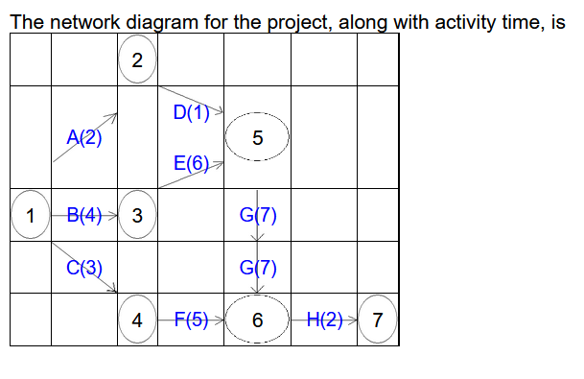Edge and it's preceded and succeeded node

|  |  |
| --- | --- |
| Edge | Node1 → Node2 |
| A | 1→2 |
| B | 1→3 |
| C | 1→4 |
| D | 2→5 |
| E | 3→5 |
| F | 4→6 |
| G | 5→6 |
| H | 6→7 |

The critical path of the project is : 1-3-5-6-7 and critical activities are *B*,*E*,*G*,*H* and total project time is 19.

|  |  |  |  |  |  |
| --- | --- | --- | --- | --- | --- |
| Activity | Duration | Earliest Start Time (EST) | Earliest Finish Time | Latest Start Time (LST) | Slack Time (EST-LST) |
| A | 1 | 0 | 1 | 3 | 3 |
| B | 4 | 0 | 4 | 0 | 0 |
| C | 3 | 0 | 3 | 1 | 1 |
| D | 2 | 1 | 3 | 6 | 5 |
| E | 4 | 4 | 8 | 4 | 0 |
| F | 5 | 3 | 8 | 9 | 6 |
| G | 6 | 8 | 14 | 8 | 0 |
| H | 3 | 14 | 17 | 14 | 0 |

# BOUNDARY VALUE ANALYSIS

## INputs are day, month and year. output will be the date (if valid) or “invalid date”.

Constraints:

1<=Month<=12  
1<=Day<=31  
2000<=Year<=2022

|  |  |  |  |  |
| --- | --- | --- | --- | --- |
| Test Case | Month | Day | Year | Expected Output |
| 1 | 6 | 15 | 2000 | 15 JUNE,2000 |
| 2 | 6 | 15 | 2001 | 15 JUNE,2001 |
| 3 | 6 | 15 | 2011 | 15 JUNE,2011 |
| 4 | 6 | 15 | 2021 | 15 JUNE,2021 |
| 5 | 6 | 15 | 2022 | 15 JUNE,2022 |
| 6 | 6 | 1 | 2011 | 1 JUNE,2011 |
| 7 | 6 | 2 | 2011 | 2 JUNE,2011 |
| 8 | 6 | 30 | 2011 | 30 JUNE,2011 |
| 9 | 6 | 31 | 2011 | INVALID DATE |
| 10 | 1 | 15 | 2011 | 15 JANUARY,2011 |
| 11 | 2 | 15 | 2011 | 15 FEBRUARY,2011 |
| 12 | 11 | 15 | 2011 | 15 NOVEMBER,2011 |
| 13 | 12 | 15 | 2011 | 15 DECEMBER,2011 |

# CYCLOMATIC COMPLEXITY pROBLEM

